Echocardiography Requisition
Louise Marshall Hospital
Fax Completed requisition to 519-943-0980

PATIENT INFORMATION:  Last Name: First Name:  DOB: (dd/mm/yyyy)  Health Card Number:  Address:  Street  City Province  Postal Code Phone:  Height:_____________ Weight:______________ |  | REFERRING PHYSICIAN:  Name:  Address:  Street  City Province Postal Code  Phone: Fax:  Additional copies:
For urgent requests please contact the department directly 519-323-2210 x 74701

Urgent  Elective 
Is this a pre-operative assessment?  No  Yes Date of Surgery (if known): __________________________________
Translator Required?  No  Yes If yes, Specify Language: ____________________________________________
ECHOCARDIOGRAPHY | ❒ Transthoracic Echocardiogram (no patient prep)
INDICATION: Check all that apply ** Requisitions without appropriate indication/clinical information will be returned**
❒ Prior MI  Cardiac Cath  CABG
❒ Valve Replacement  Mechanical  Tissue Model:________________________
❒ Chest pain  Dyspnea  Palpitations  AFib  Syncope
❒ Murmur:__________________________________________
❒ LV dysfunction  Cardiomyopathy  Aortic Disease  Source of embolus  Pericardial Disease
❒ Chemotherapy
❒ LVH  RV dysfunction  Congenital  Pulmonary HTN
❒ Valve Disease: _______________________________________
❒ Cardiac screening for asymptomatic patients with multiple cardiovascular risk factors (select all that apply):
Smoker Diabetic Dyslipidemia Hypertension  Stroke/TIA  PVD  Family History CAD
❒ Abnormal ECG
CLINICAL INFORMATION:

Physician’s Signature: Date: _
Office Use Only
Date Received: Scheduled Appointment: Patient Notified 

Suggested Chest Pain Assessment Algorithm (Excluding Acute Coronary Syndromes)

STEP 1. Estimate Pretest Probability of Obstructive Coronary Disease as the cause for the patient’s chest pain:

Chest Pain Characteristics:  - Substernal chest discomfort, with characteristic quality and duration  - Provoked by exertion or emotional stress  - Relieved by rest and/or Nitroglycerine | Non-Anginal Chest Pain ≤ 1 of 3 Atypical Chest Pain 2 of 3 Typical Anginal Chest Pain 3 of 3  Age Male Female Male Female Male Female  30-39 4% 2% 34% 12% 76% 26%  40-49 13% 3% 51% 22% 87% 55%  50-59 20% 7% 65% 33% 93% 73%  60-69 27% 14% 72% 51% 94% 86%
STEP 2. Determine the appropriate non-invasive risk stratification method:
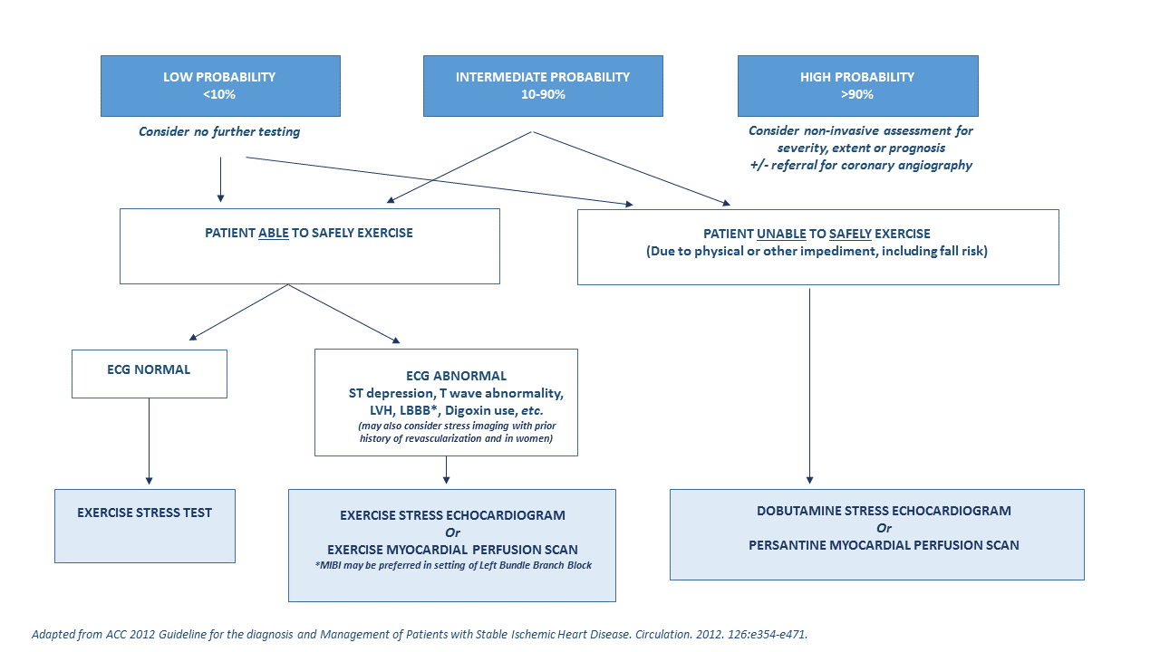

Stress Test with Consultation & +/- Consultation Services:
- Appropriate for the evaluation of patients presenting with chest pain or dyspnea with intermediate to high pre-test probability of obstructive CAD
- Cardiovascular screening for asymptomatic patients with multiple cardiovascular risk factors
- Pre-operative cardiac assessment, in patients with multiple cardiovascular risk factors or known CAD, not currently followed by a Cardiologist, WHEN it will change management
- +/- Consultation means a consultation will be provided in the event of a high risk study
- Stress test with Consultation service is NOT appropriate for patients who are currently being followed and managed by a Cardiologist. In this case, either refer directly to that physician’s office or order a test only, with the results copied to the patient’s usual Cardiologist

