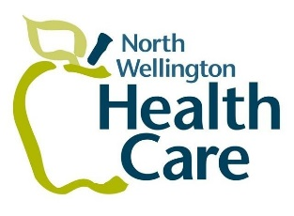
Media Release
For immediate release
Tuesday, February 23, 2022
Mount Forest, ON…The North Wellington COVID-19 Assessment and Vaccination Centre, located in Harriston, is moving to Louise Marshall Hospital, and reducing their hours starting on February 24th, 2022.
The Harriston location will close on February 24th and the new location will open on Tuesday, March 1st, 2022, at 9:00 am.
“The assessment and vaccination centre will continue to offer COVID-19 PCR testing for those who are eligible and vaccinations to anyone in need.” explains Angela Stanley, President and CEO of North Wellington Health Care. The new location will be open Tuesdays, from 9:00 am to 5:00 pm (closed for lunch from 12:30 pm to 1:30 pm).
“We would like to thank the Town of Minto for providing the space in Harriston since October 2020,” remarks Stanley. “The demand for testing has decreased due to the changes to the provincial guidelines for who can receive a PCR test. We are fully aware things could change at any time and we are prepared to ramp up again, if needed.”
To book an appointment or for further information of the North Wellington COVID-19 Assessment and Vaccination Centre please visit www.whcacovid.com
-30-
Media contact:
Alison Armstrong
(226) 820-1798

